#EBS
Elastic block storage
EBS (Elastic Block Store) is the hard disk of an EC2 instance. It stores data in small blocks.
EBS = Hard disk of EC2
Stores data in small blocks
Data remains safe even if EC2 is stopped
--------------------------------------------------------------------------------------------------------------
Volume:
EBS provides volumes, and an EBS volume is like the hard disk of an EC2 instance
--------------------------------------------------------------------------------------------------------------

Volumes types #IMP
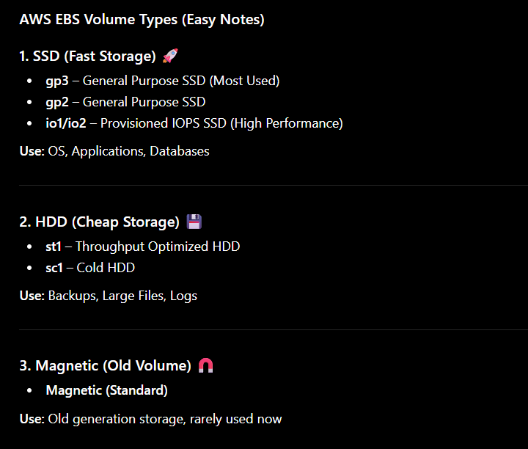
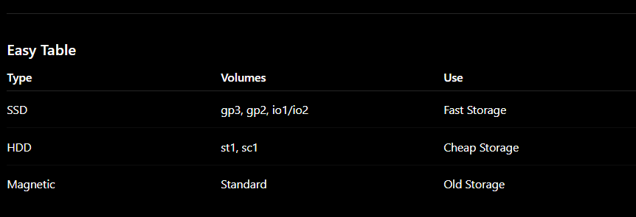
Instance attached to volume
EBS Volume is the hard disk of your EC2 instance. Whatever data you store in the EC2 instance is saved in the EBS volume. If the EBS volume is deleted, the data is lost. To protect the data, we create an EBS Snapshot, which acts as a backup.
For now snapshot is like a making backup of your instance

Types of partitions:
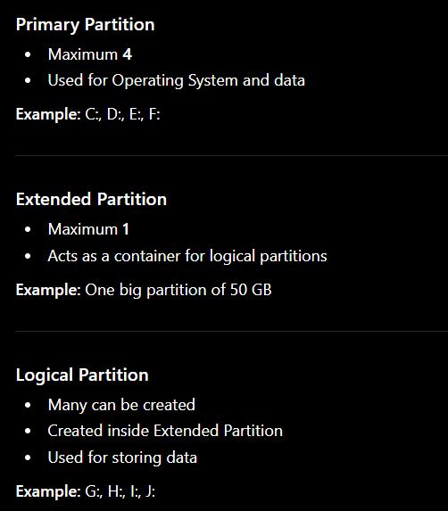
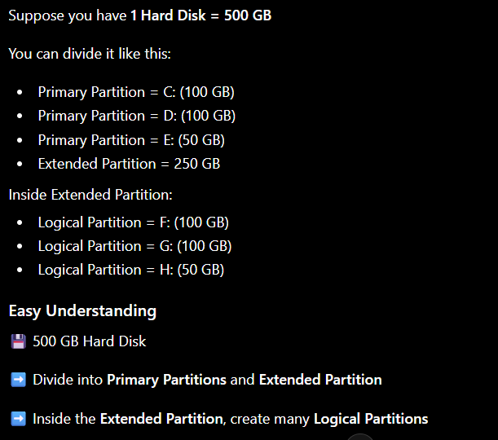
Create and Attach EBS Volume
- Launch an EC2 Instance 🖥️
- Go to Elastic Block Store (EBS) → Volumes
- Click Create Volume
- Select Size (e.g., 20 GB)
- Create Volume
- Select the Volume → Attach Volume
- Choose your existing EC2 Instance
✅ Now your EC2 instance has additional storage space.
Student Answer
"First launch an EC2 instance. Then create a new EBS volume and attach it to the existing EC2 instance. This provides additional storage space to the server." ✅
Easy understanding:
🖥️ EC2 = Computer
💾 EBS Volume = Extra Hard Disk
Attach a new EBS Volume = Add a new hard disk to the computer. 👍
--------------------------------------------------------------------------------------------------------------

How to create and mount

Steps to Use a New EBS Volume (Easy)
1. Launch EC2 Instance
- Create a virtual server in AWS
- 2. Create EBS Volume [ EBS Volume and EC2 Instance must be in the same Availability Zone (AZ).
]
- Create a new hard disk (storage)3. Attach Volume to EC2
- Connect the new hard disk to the server
4. Connect to EC2
- Login to the Linux server
5. Check Attached Disk
lsblk
lsblk = List Block Devices
- Shows all attached disks and volumes
6. fdisk /<dev>/<volume name>
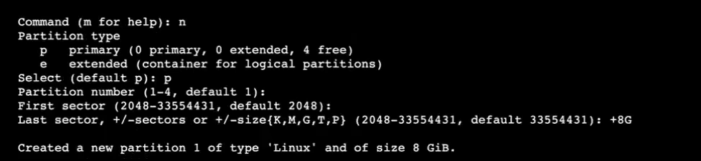9. Verify
df -h
df = Disk Free
- Shows mounted storage and available space

Easy Student Answer
"First launch an EC2 instance. Then create and attach an EBS volume. Connect to the instance, check the volume using lsblk, format it using mkfs, create a directory using mkdir, and mount the volume using mount. After mounting, the new storage can be used by Linux." ✅
Shortcut
Create Volume → Attach Volume → lsblk → mkfs → mkdir → mount → df -h ✅

Launch ec2 instnace
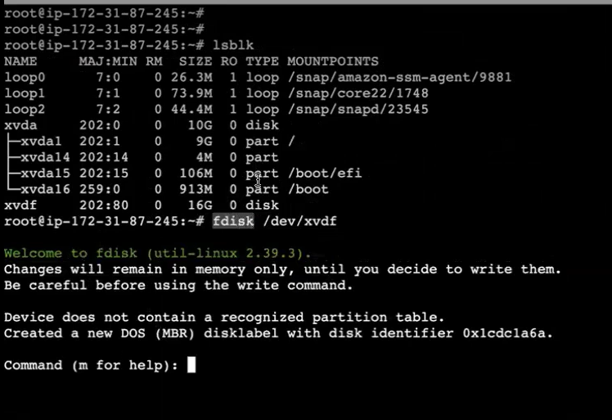
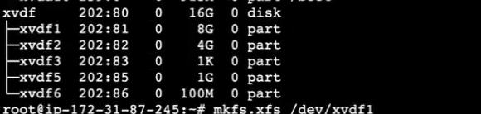 1st partition name is xvdf so we will write
Mkfs.xfs /dev/xvdf1
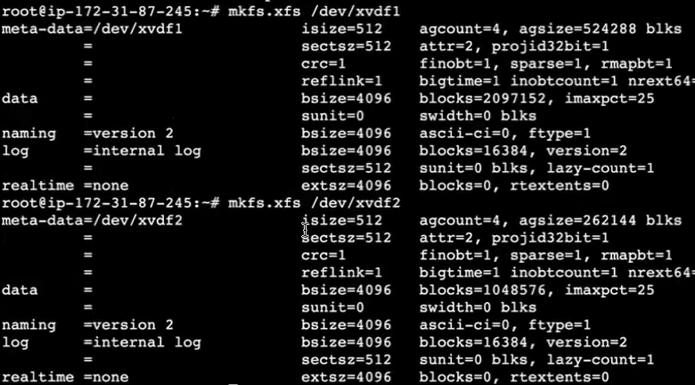
Same for xvdf2 xvdf 3 xvdf 4 xvdf 5 xvdf 6 etc

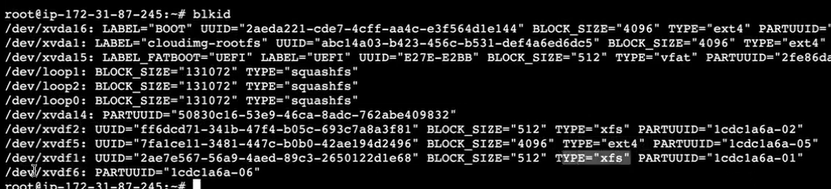
Blkid to check
We successfully formatted the partition. By running mkfs.ext4, we created an Ext4 filesystem on the partition. Now the partition is ready to store files, but it is not yet usable until we mount it."
Short version:
Partition Created ✅
Filesystem Created (Format) ✅
Mount Pending ⏳
But what is this xfs and ext4 ?
mkfs.ext4 → Format partition using EXT4 filesystem
mkfs.xfs → Format partition using XFS filesystem
Both do the same main job:
✅ Create a filesystem on the partition
✅ Prepare the partition to store files
✅ Allow the partition to be mounted
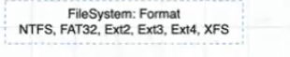
Some more filesystem that is used for formatting partition

NOW LETS MOUNT IT
- PREVIOUSLY WE CREATED (STEP 1)
- VOLUME THEN ATTACHED IT TO OUR EC2 INSTNACE ( STEP 2 )
- THEWE CREATED PARTITION OF THAT VOLUME ( STEP 3)
- THEN FORMAT IT (STEP 4)
- NOW LETS MOUNT IT (STEP 5)
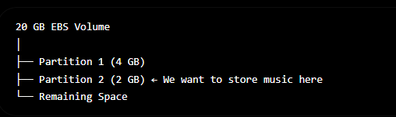
I want my one partition for music I want to store my music in that directory so first
Create music directory
Mkdir music
2nd step
mount /dev/xvdf /music
now lets check
df -hT
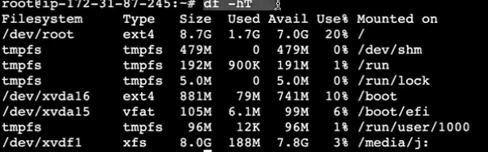-> LETS THINK THIS /media/j: is our music folder
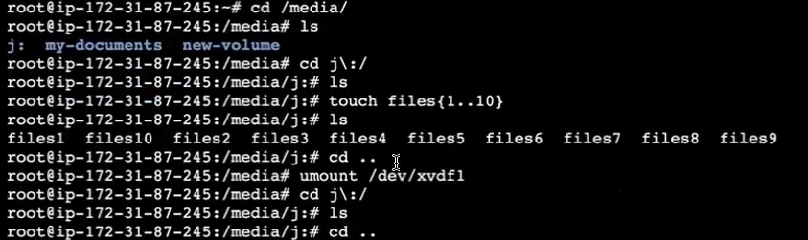
Think “j:” is our “music” folder
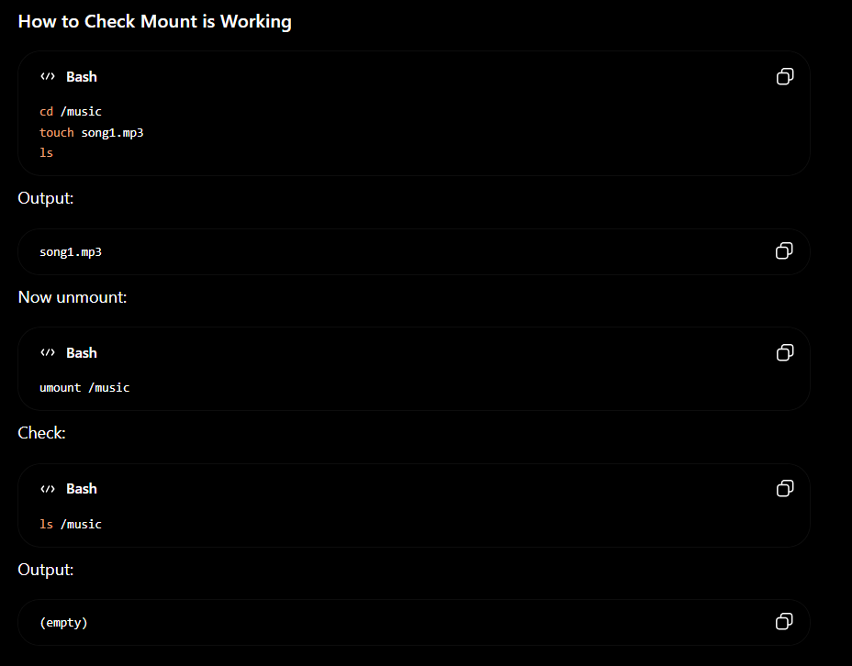as you can see when we unmount it files that we created are gone 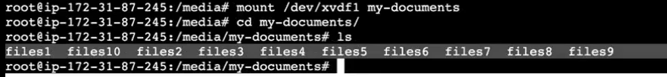now lets think I want to mount in my_documents directory
so you can mount /dev/xvdf my_doucments
and you will see that the files that are in my_documents
how j: directory files came in my_documets because you just created new directory but that data was in that partition like pendrive
you insert some data in pendrive then you took that pendrive inanother computer same data youn will get
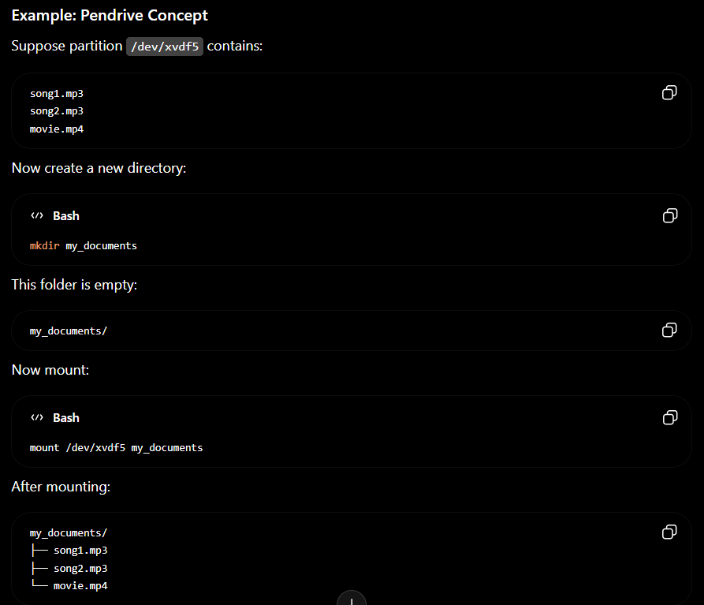
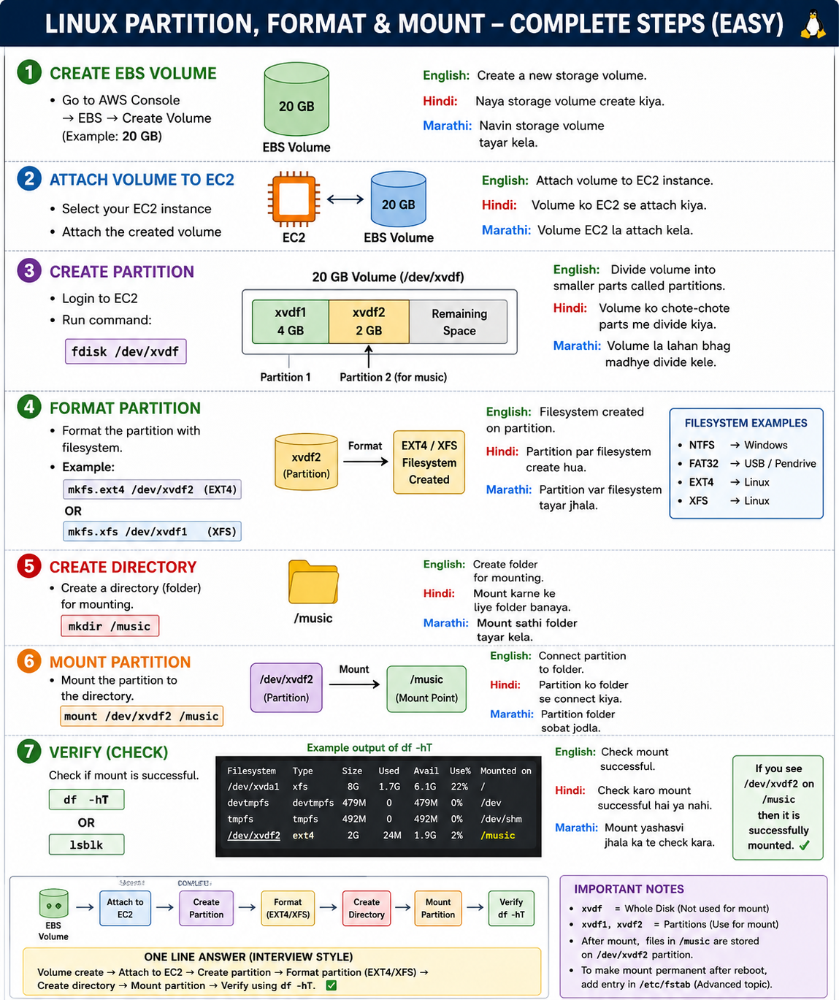

But !!!!!!
This mount is temporary when you reboot your instance the mount will be unmount

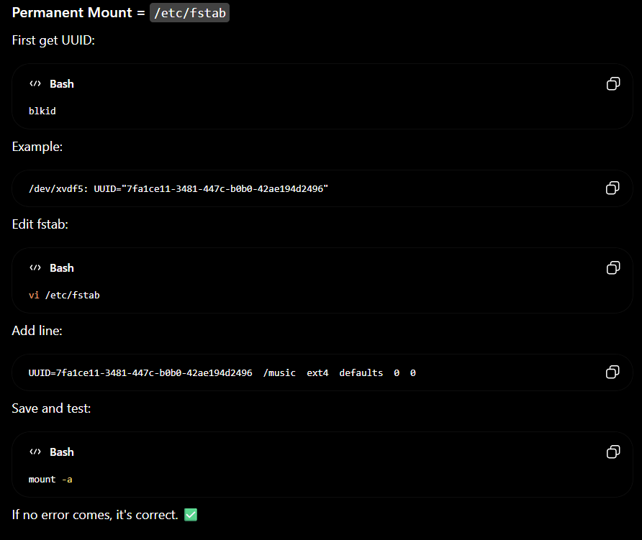
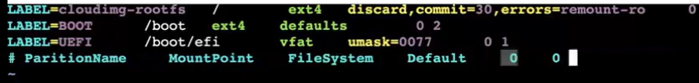
What is means by this 0 0
Remember don’t give # partition mountpoint etc this is just an example
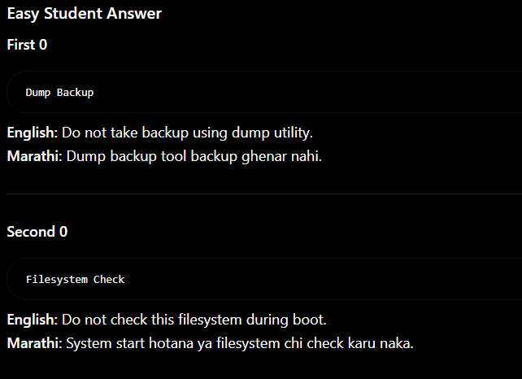
Run blkid and get the UUID of the partition mounted on /music.
Then add it in /etc/fstab:
UUID=7fa1ce11-3481-447c-b0b0-42ae194d2496 /music ext4 defaults 0 0
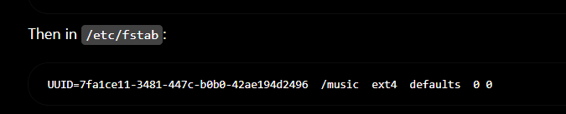
1:13

